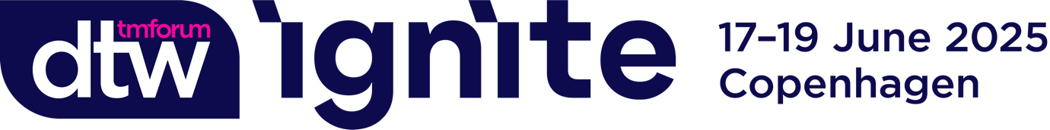

Dear [Your manager’s name],
I would like to attend TM Forum’s flagship event DTW Ignite in Copenhagen from 17-19 June 2025 to help support me in achieving my [add project(s) or initiative(s) for performance targets/lead gen/build pipeline/network/key learnings].
Our industry is on a mission for growth, and DTW Ignite is where I’ll find our path.

Whether it is agility through Composable IT & Ecosystems, efficiency through Autonomous Networks, or innovation with AI and Data, I’ll be inspired, learn from others, and get hands-on at DTW Ignite with these proven pathways to growth beyond profit.

I’ll join the industry’s biggest alliance as we face challenges, delve into solutions, and deliver real change together.

The best part is that I can receive a complimentary All Access Pass if I take part in Executive Connect, during the event.
Executive Connect is a meeting program, where TM Forum connects selected service providers and leading solution providers, via one-to-one meetings. I will be able to learn about new technologies, which could be of great interest to us.
The facts:
- 79% of all attendees are managers or above.
- 10 out of 10 of the largest global operators will be there.
- 75% of past visitors rated the quality of the event as excellent or good.
DTW Ignite is where the most powerful conversations and connections happen in real life. Here’s how it can take us to new heights:
- Calibrate our strategy: With over 200 experts across 60 hours of content, it’s a great place to learn about the wider industry. This is where trailblazers come to share, I’ll be immersed in all the learnings, presentations, demos, debates, and case studies. The biggest conversations shaping the future of telecoms happen at this event.
- Harness the power of connecting: As an attendee, I will have access to the event app, allowing me to plan my time and connect and meet other like-minded delegates. There are also numerous other networking opportunities over the three days, which I will take full advantage of, including the new Solutions Room, powered by BrainDates. In the Solutions Room, I’ll be able to connect with industry experts online and in person. There will be one-on-one or small group discussions to tackle real challenges and uncover actionable solutions.
- The who’s who of telecoms: Over 600 companies and 4,000 delegates from across telecoms will attend, from over 100 countries. From C-Suite global leaders to DevOps new challengers and from tech giants to disrupting start-ups, this is the community that will define what’s next. The efficiency of attending the show, and access to over 1750 decision-maker delegates, would allow us to streamline two months’ worth of meetings in just three days!
After attending, I’ll gladly share what I’ve learned with my colleagues and will help identify how we can implement the best practices, skills, and ideas I return with.
Thank you for considering my request. I look forward to your reply.
Best regards,
[Your Name]

