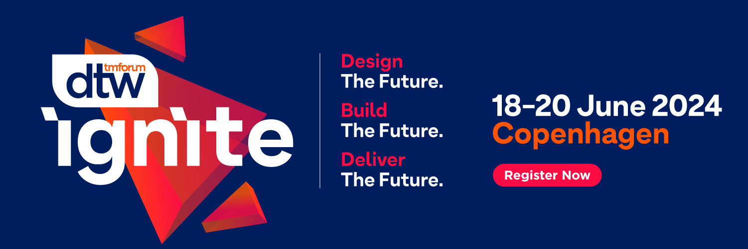

Dear [Your manager’s name],
I would like to attend TM Forum’s flagship event DTW24 - Ignite from 18-20 June 2024 to help support me in achieving my [add project(s) or initiative(s) for performance targets/lead gen/build pipeline/network/key learnings].
DTW24 - Ignite is not just an event; it’s the global summit where our industry connects with animated exchange, collaborates with unrivalled productivity, challenges the status quo, and convenes as a community with energy that is electrifying. .
I can receive a complimentary All Access Pass if I take part in Executive Connect, during the event.
Executive Connect is a meeting program, where TM Forum connect selected service providers and with leading solution providers, via one-to-one meetings. I will be able to learn about new technologies, which could be of great interest to us.
The facts:
- 79% of all attendees are manager or above.
- 10 out of 10 of the largest global operators will be there.
- 75% of past visitors rated the quality of the event as excellent or good.
DTW24 - Ignite is where the most powerful conversations and connections happen in real life. Here’s how it can take us to new heights:
- Calibrate our strategy: With over 300 experts across 60 hours of content, it’s a great place to learn about the wider industry. This is where trailblazers come to share, I’ll be immersed in all the learnings, presentations, demos, debates, and case studies. The biggest conversations shaping the future of telecoms happen at this event.
- Harness the power of connecting: As an attendee I will have access to the event app allowing me to plan my time and connect and meet other likeminded delegates. There are also numerous other networking opportunities over the three days which I will take full advantage, including social activities, quizzes, interactive demos and more.
- The who’s who of telecoms: Over 600 companies and 4,000 delegates from across telecoms will attend, from over 100 countries. From C-Suite global leaders to DevOps new challengers and from tech giants to disrupting start-ups, this is the community that will define what’s next. The efficiency of attending the show, and access to over 1750 decision maker delegates, would allow us to streamline two months’ worth of meetings in just three days!
After attending, I’ll gladly share what I’ve learned with my colleagues, and will help identify how we can implement the best practices, skills, and ideas I return with.
Thank you for considering my request. I look forward to your reply.
Best regards,
[Your Name]

